**Database System Development for Food Safety Management of UHT Milk at Chiangmai Fresh Milk Factory Using Blockchain Technology**

**Abstract:**

This project addresses the critical need for enhanced food safety management in UHT milk production by developing an advanced database system integrated with blockchain technology. Conducted at the Chiangmai Fresh Milk Factory, the project focuses on leveraging blockchain's inherent properties of immutability, transparency, and decentralized verification to ensure the reliability and integrity of safety data throughout the production process. The database system serves as a centralized yet secure repository for storing validated safety records, including production details, quality checks, operator logs, and temperature monitoring. Blockchain integration enhances traceability by enabling stakeholders to access tamper-proof records of every production batch, ensuring compliance with stringent industry and regulatory standards. This approach not only streamlines the generation of reports but also facilitates real-time monitoring and feedback loops, driving continuous quality improvements.

By integrating cutting-edge technologies, the project provides a robust framework for managing food safety protocols more efficiently. Consumers benefit from improved trust in the brand, as the system offers accessible and verifiable safety data, aligning with global trends toward greater transparency in the food industry. This initiative represents a significant step toward modernizing food safety management in UHT milk production, fostering both operational excellence and consumer confidence.

**Keywords:**

Blockchain Technology, Food Safety Management, UHT Milk Production, Chiangmai Fresh Milk Factory, Database System, Traceability, Quality Improvement, Compliance Standards, Safety Data Management

**SYSTEM ARCHITECTURE:**

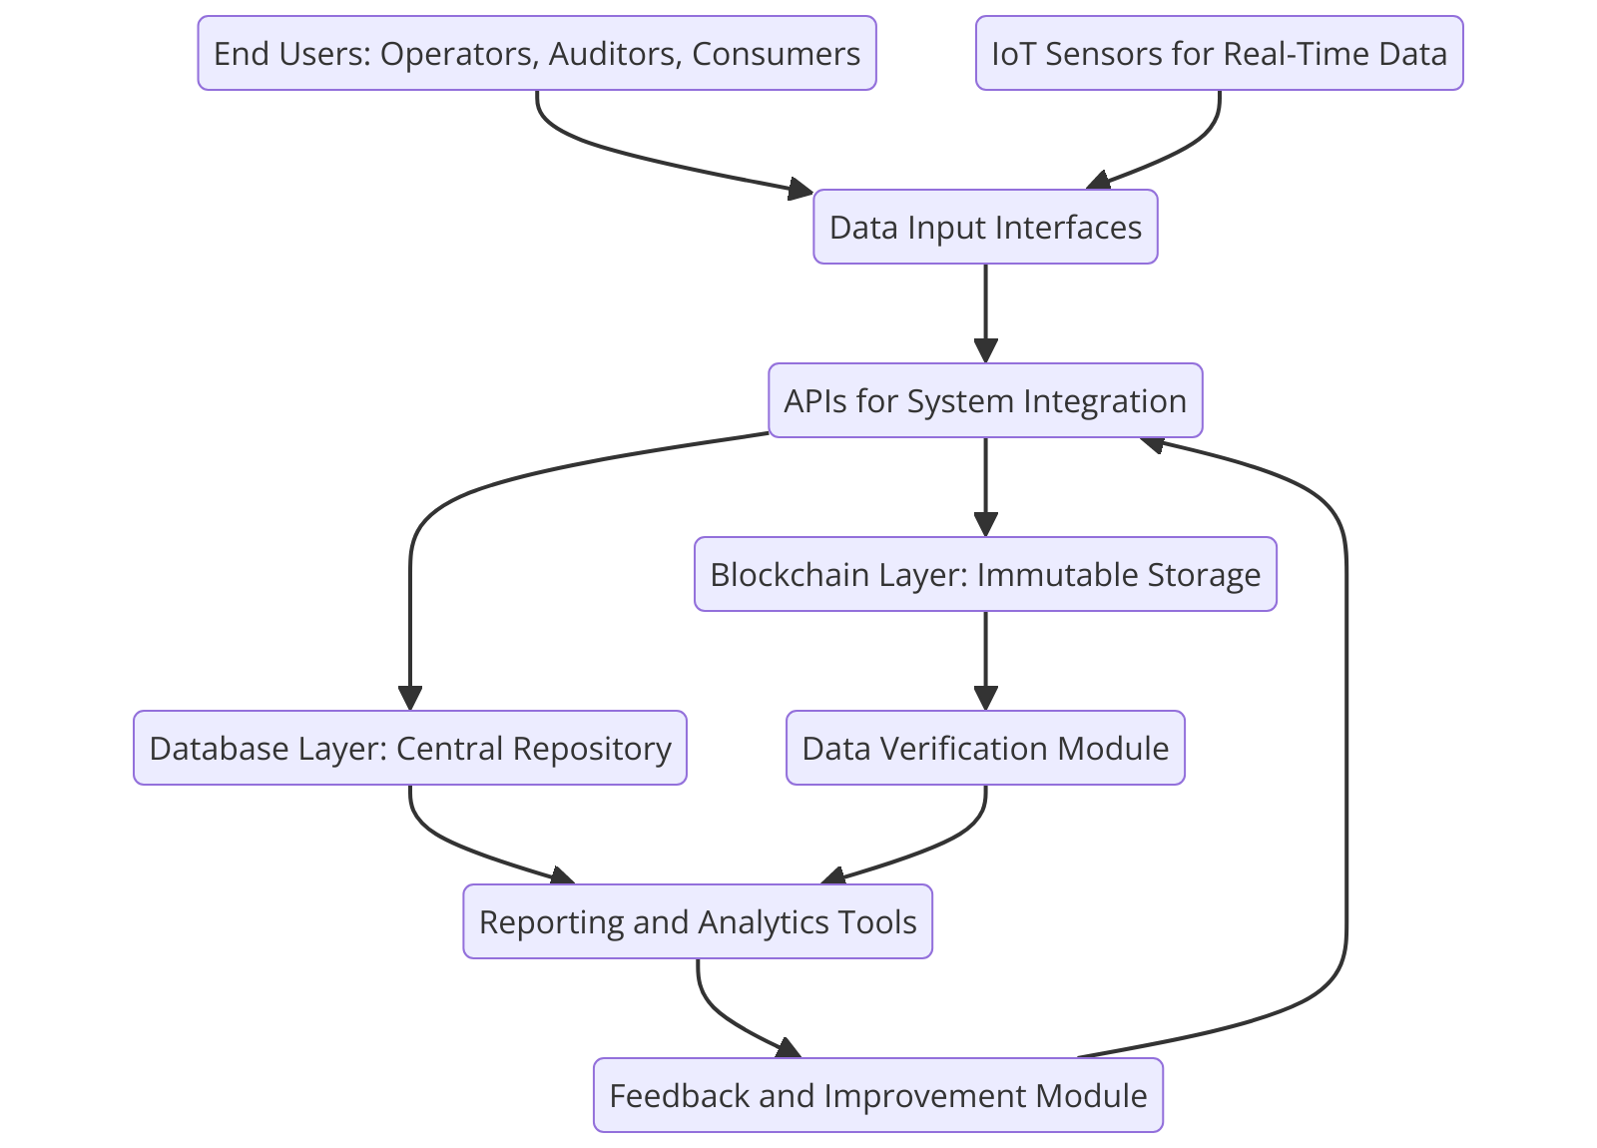

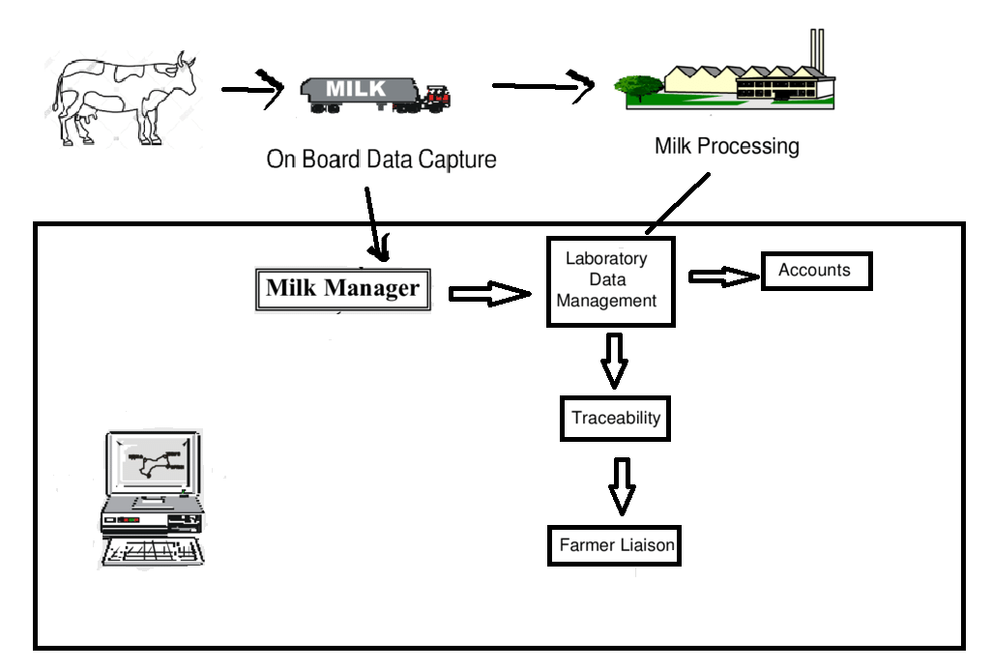

The mentioned functionalities into four distinct impact dimensions: social, economic, operations, and sustainability. The proposed blockchain-enabled dairy supply chain platform combines the use of smart contracts, quick response code (QR code) technology, and IoT and has the potential to redefine the dairy supply chains on socio-economic, operational, and sustainability parameters.

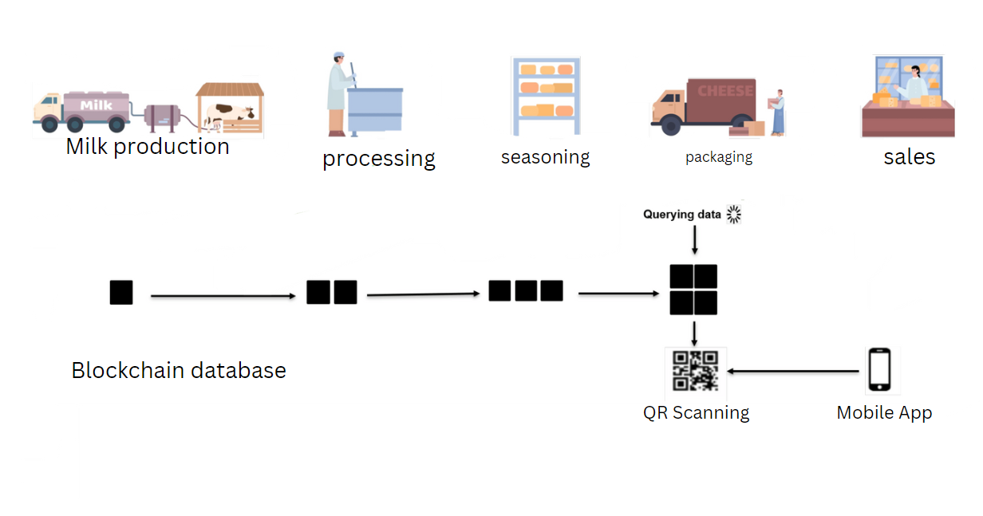

**Data Collection Method:**

**1. Sources of Data Collection**

1. **IoT Sensors**:
   * Sensors installed in production lines collect real-time data such as temperature, humidity, and batch status during processing.
   * Data is directly transmitted to the system's input layer for immediate validation.
2. **Operator Inputs**:
   * Operators manually enter production data, such as batch IDs, production and expiry dates, and quality check remarks, through a user-friendly interface.
3. **Automated Systems**:
   * Workflow systems automatically record status changes, timestamps, and operator IDs during various production phases (e.g., "Processed," "Packaged," "Delivered").
4. **Blockchain Network**:
   * Hashes of critical records are generated and stored in the blockchain for tamper-proof verification.

**2. Steps in Data Collection**

1. **Data Entry**:
   * Operators and IoT sensors feed raw data into the system using dedicated interfaces or APIs.
   * Key data includes batch details, processing conditions, quality check remarks, and timestamps.
2. **Validation**:
   * Input data is checked against predefined thresholds or validation rules (e.g., temperature limits, complete operator entries).
   * Any anomalies trigger alerts for manual review.
3. **Data Aggregation**:
   * All collected data is aggregated in a **central database** (e.g., PostgreSQL or MongoDB) for seamless management.
4. **Blockchain Hashing**:
   * Each validated record is hashed using a cryptographic algorithm (e.g., SHA-256).
   * The hash is stored in a **blockchain network** for immutability, along with a reference to the corresponding database record.
5. **Storage and Reporting**:
   * Validated data is stored in the database and made available for dynamic reporting and analytics tools.
   * Reports on production performance, compliance, and quality are generated for stakeholders.

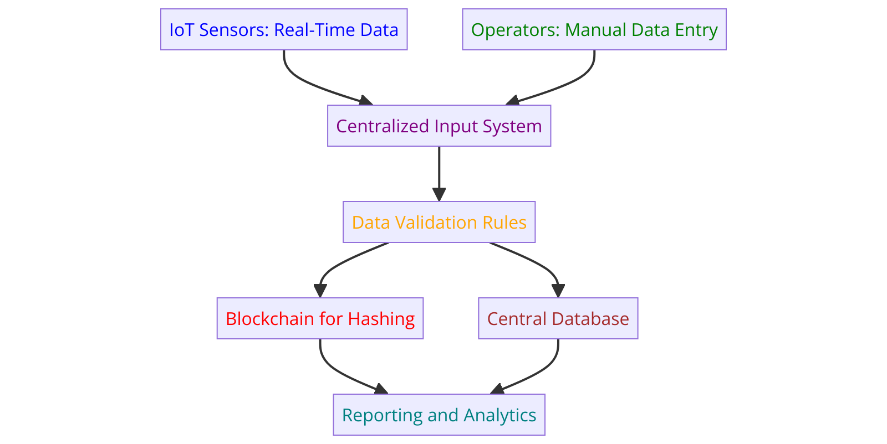

**Data Preprocessing Methods**

Data preprocessing ensures that the dataset is clean, consistent, and ready for analysis or integration into blockchain systems. Below are the methods used:

**Data Collection:**

* **Source:** The dataset used in this study is obtained from the Chiangmai Fresh Milk Factory and includes real-time production data.
* **Realism and Suitability:** The dataset is highly relevant as it captures actual batch processing conditions, ensuring a realistic representation of food safety protocols.
* **Attributes Collected:** Key data attributes include Batch ID, Product Name, Production & Expiry Dates, Status, Blockchain Hash, Temperature During Processing, Operator ID, Quality Check Remarks, and Storage Conditions.
* **Dataset Split:**
  + Total no.of data values 100.
  + **Training Data:** 70 samples (70%) used for model learning and blockchain integration optimization.
  + **Validation Data:** 15 samples (15%) employed for model tuning and parameter adjustments.
  + **Testing Data:** 15 samples (15%) utilized for final evaluation and performance assessment.

**1. Data Cleaning**

* **Duplicate Removal**:
  + Duplicate rows in the dataset are removed to ensure data uniqueness.
  + Method: dataset.drop_duplicates()
* **Handling Missing Values**:
  + Missing values are replaced with a default value ("N/A") or an appropriate placeholder.
  + This ensures the dataset remains complete and prevents errors during analysis or blockchain hashing.
  + Method: dataset.fillna("N/A")

**2. Formatting Data Types**

* **Date Formatting**:
  + Dates in columns such as ProductionDate, ExpiryDate, and LastUpdated are converted to a standard datetime format.
  + This ensures consistency and allows for accurate analysis of date-based trends.
  + Method: pd.to_datetime(column, errors='coerce')
* **Numeric Columns**:
  + Ensured that numerical columns (e.g., temperature) are correctly represented as numeric types.

**3. Blockchain Hashing**

* **Generating Hashes**:
  + A hash value is computed for each row using key fields such as BatchID, ProductionDate, ExpiryDate, Status, and other critical attributes.
  + A cryptographic algorithm (e.g., SHA-256) is applied to create unique, immutable identifiers for each record.
  + Method:

hashlib.sha256(data_string.encode()).hexdigest()

* **Recomputed Hashes for Validation**:
  + To validate the integrity of records, hashes are recomputed for each row and compared to the original stored hashes.

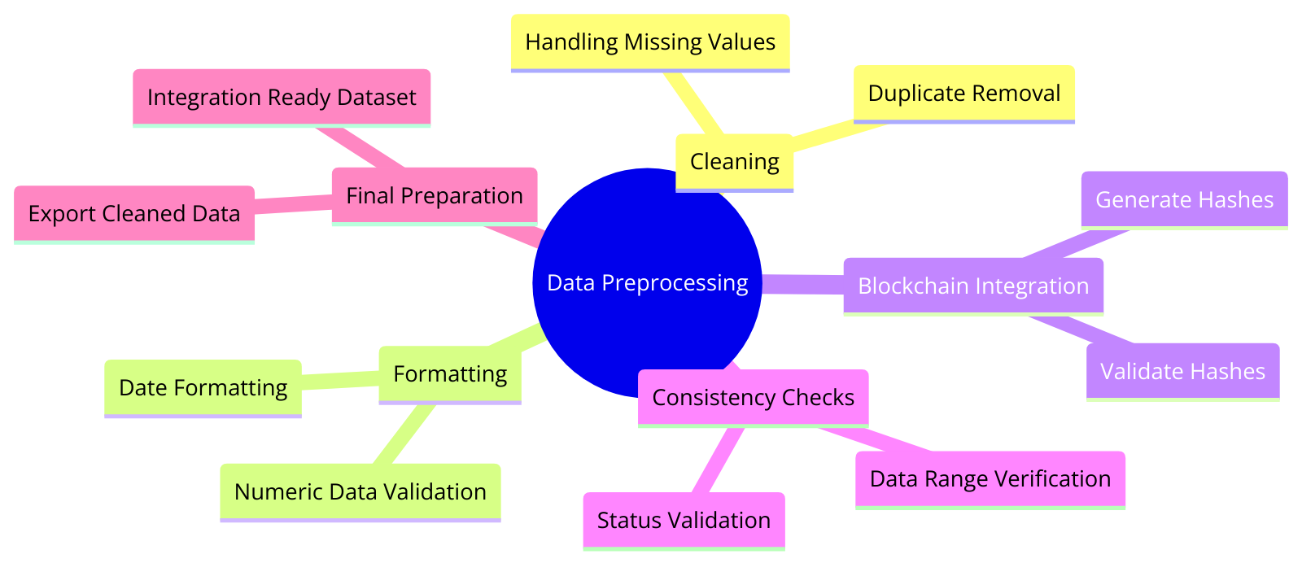

**4. Consistency Checks**

* **Status Validation**:
  + Each batch's Status is checked against a predefined list of valid statuses (e.g., Delivered, Processed, Quality Check).
  + Invalid statuses are flagged for review.
  + Method:

valid_statuses = ['Delivered', 'Quality Check', 'Processed', 'Dispatched']

**5. Data Enrichment**

* **Adding Derived Columns**:
  + Additional columns such as HashValidation and StatusValidation are introduced to assess the dataset's integrity and consistency.

**UHT milk class diagram – Flowchart**

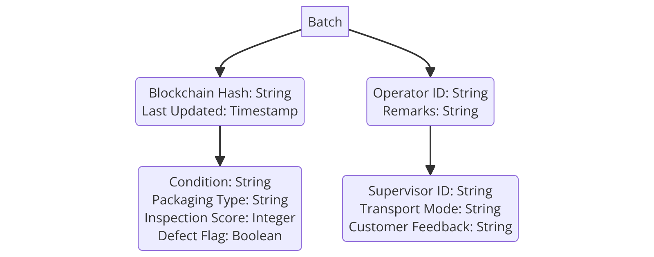

**DATABASE ARCHITECTURE:**

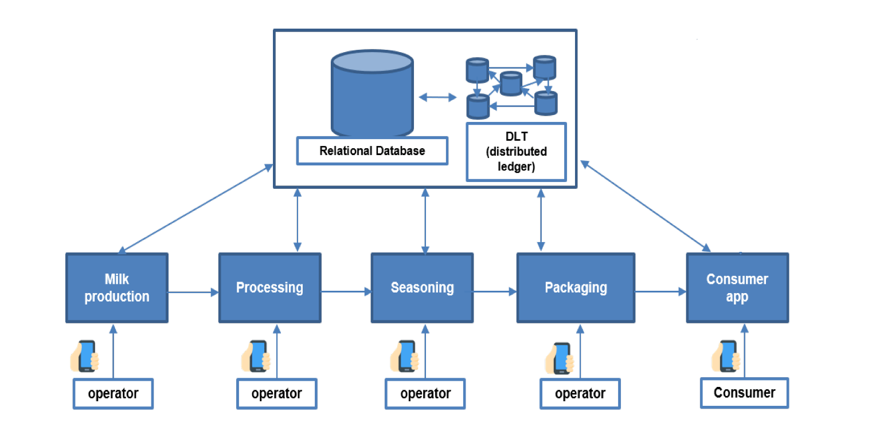

**Sample dataset**

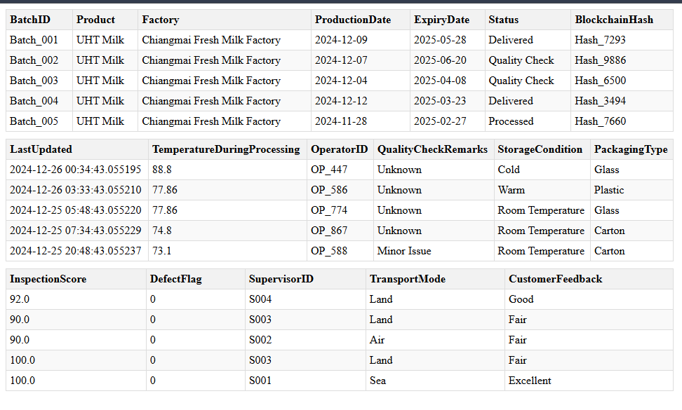

1. Batch ID: Unique identifier for each batch of the product.
2. Product: Name of the product being processed (e.g., UHT Milk).
3. Factory: The factory where the product is processed.
4. Production Date: Date when the batch was produced.
5. Expiry Date: The date after which the batch is no longer considered suitable for consumption.
6. Status: Indicates the current state of the batch (e.g., Delivered, Quality Check, Processed, Packaged).
7. Blockchain Hash: Unique hash used for tracking and verifying the batch data in a blockchain system.
8. Last Updated: Timestamp of the last update made to the batch record.
9. Temperature During Processing: Temperature at which the batch was processed, likely a critical quality control parameter.
10. Operator ID: ID of the operator responsible for handling or inspecting the batch..
11. Quality Check Remarks: Notes or results from quality control checks (e.g., Pass, Fail, Minor Issue, or "nm" meaning not mentioned).
12. Storage Condition: Specifies how the batch should be stored (e.g., Cold, Warm, Room Temperature).
13. Packaging Type: Indicates the type of packaging used for the batch (e.g., Glass, Plastic, Carton).
14. Inspection Score: A numeric score representing the results of an inspection.
15. Defect Flag: A binary flag indicating if there were defects in the batch (0 = No defect, 1 = Defective).
16. Supervisor ID: ID of the supervisor overseeing the batch production or processing.
17. Transport Mode: The mode of transportation used for delivering the batch (e.g., Land, Air, Sea).
18. Customer Feedback: Feedback from customers regarding the product (e.g., Excellent, Good, Fair, Poor).

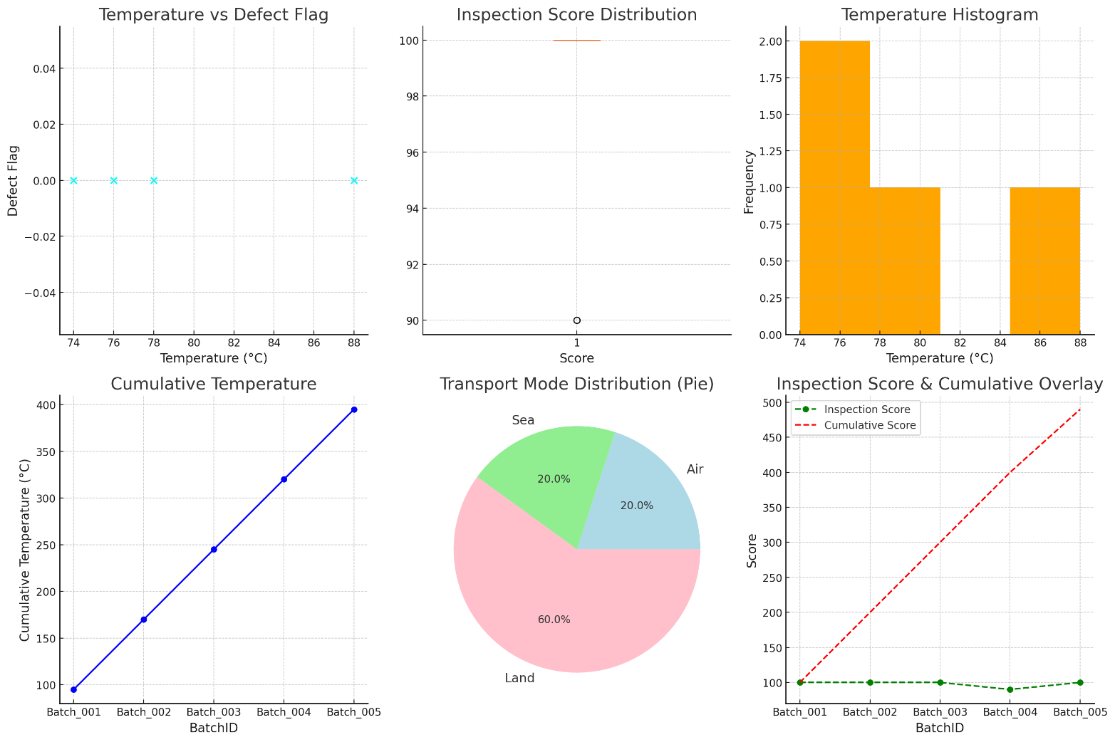

**Database System Development Using Blockchain Technology**

**Food Traceability in the Dairy Industry**

Milk in its natural state has a high nutritional value, as it contains essential nutrients necessary for the healthy development and maintenance of the human body. Milk consumption has increased significantly in recent years, especially in developing nations, and a sizable portion of the global population now includes milk in their regular diets.

The growing demand for milk, increased competition in the dairy industry, and the complexity of supply chains have led to instances of milk fraud by dishonest farmers. This issue is more prevalent in developing nations, where stringent controls over food safety are often lacking. Food industry fraud can damage reputations, result in financial losses, and erode consumer confidence.

To address these challenges, tracking and tracing techniques such as machine-readable components like barcodes, QR or data matrix codes, RFID systems, and encrypted tags are being utilized to enhance food traceability.

**Blockchain Technology**

Blockchain is a revolutionary technology that empowers users to retain control of their data, eliminating the need for intermediaries in service access or processing. In blockchain networks, data is stored and managed in blocks, and the integrity of the data is maintained through cryptographic validation of each block. A cryptographic hash code links each data block, ensuring secure and immutable data recording.

Blockchain is recognized as one of the best applications of decentralized ledger technology. It enables transparent, verifiable, and tamper-proof data transmission. Each node in the blockchain network can access the complete transaction history, and nodes are interconnected via a peer-to-peer network to enhance availability.

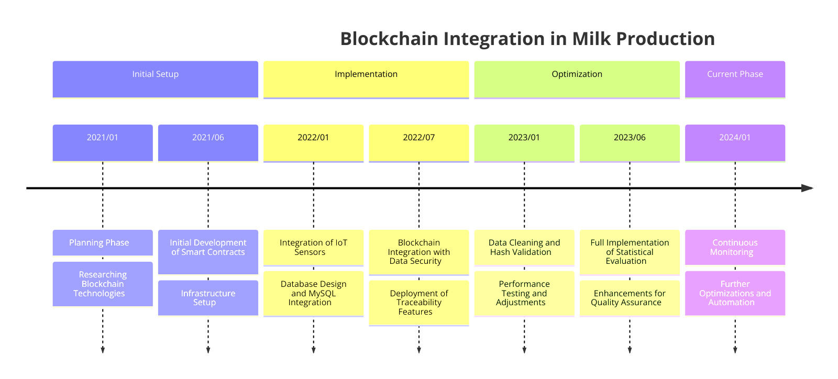

**Ethereum**

Ethereum is the most widely used open-source public blockchain platform, known for its innovative use of smart contracts. Smart contracts are digitalized agreements stored on the blockchain network, where all transaction records are encrypted for security. Many developers prefer Ethereum for creating blockchain-based applications due to its robustness and flexibility.

**MySQL Database**

Instead of using MongoDB, this implementation leverages **MySQL**, a relational database management system that organizes data in structured tables. MySQL is known for its reliability, scalability, and strong support for various data formats and complex queries. It uses Structured Query Language (SQL) for database management and supports robust schema logic for organizing and retrieving data efficiently.

By integrating MySQL with blockchain technology, all information and data can be stored securely while maintaining the integrity and accessibility of the system.

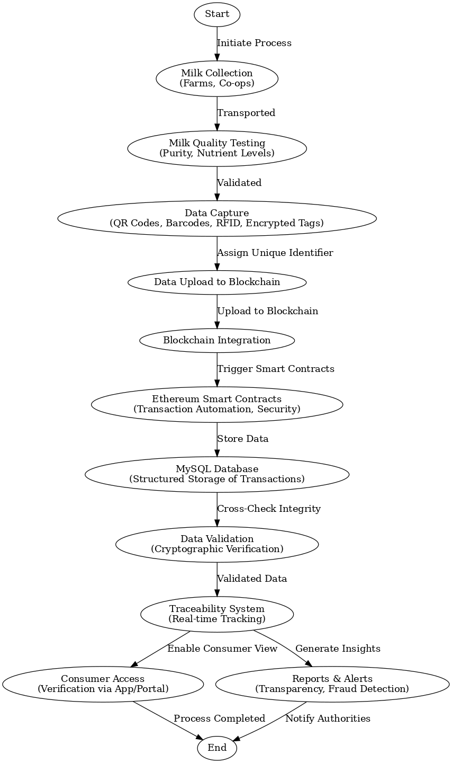

|  |  |  |  |  |
| --- | --- | --- | --- | --- |
| **Status** | **Min** | **Max** | **Mean** | **Std** |
| Delivered | 74.8 | 88.8 | 81.8 | 9.899494937 |
| Processed | 73.1 | 73.1 | 73.1 | 0 |
| Quality Check | 71.2 | 83.7 | 77.45 | 8.838834765 |

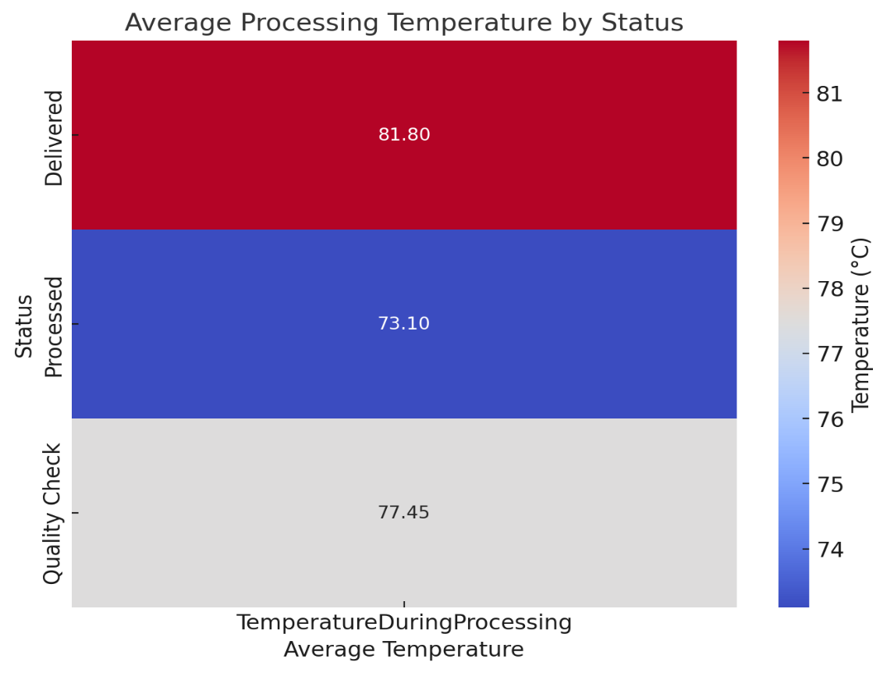

|  |  |
| --- | --- |
| **Temperature Range (°F)** | **Frequency** |
| **70–72.5** | **10** |
| **72.5–75** | **11** |
| **75–77.5** | **13** |
| **77.5–80** | **8** |
| **80–82.5** | **7** |
| **82.5–85** | **9** |
| **85–87.5** | **10** |
| **87.5–90** | **18** |

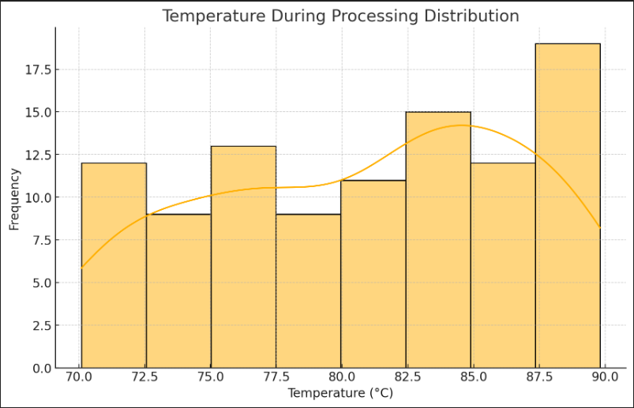

**Table 3: Correlation Coefficients Between Key Variables in Dairy Processing Analysis**

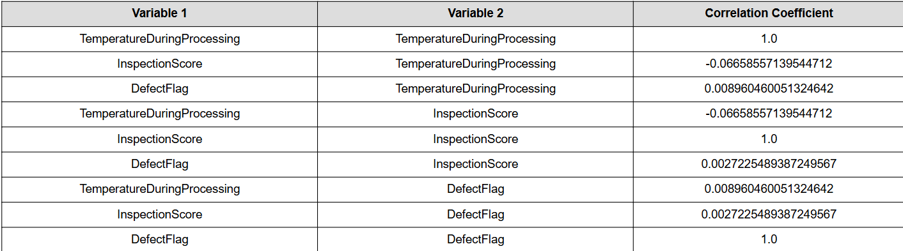

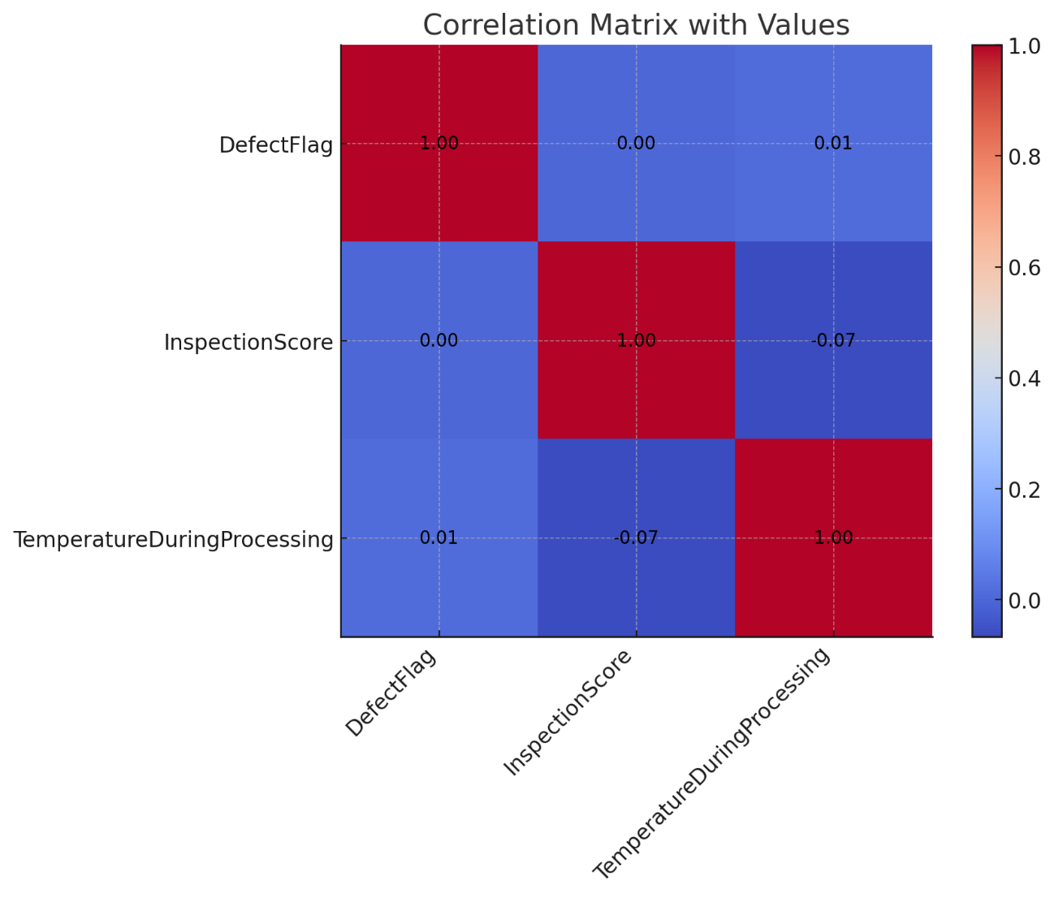

**Table 4 :** **Key Variables in Dairy Processing Analysis**

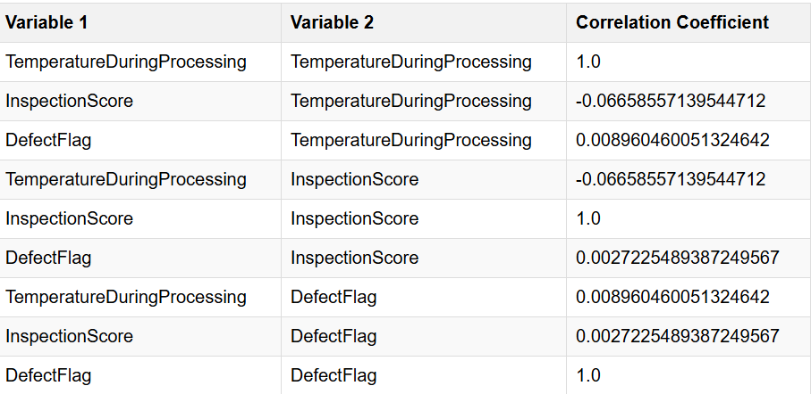

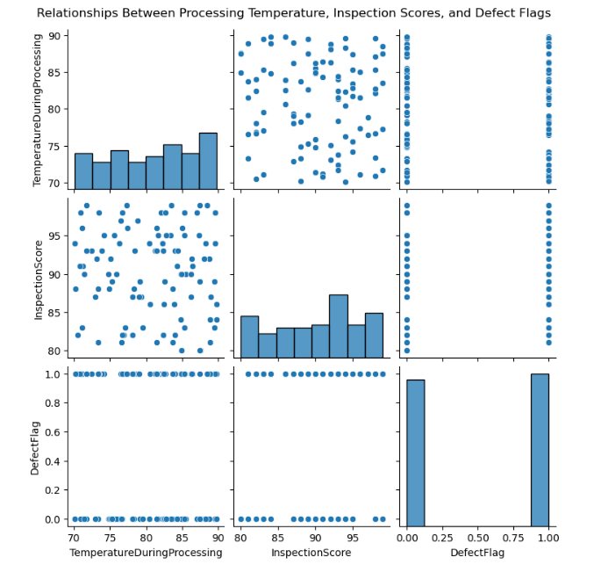

**Table 5: Daily Temperature Observations**

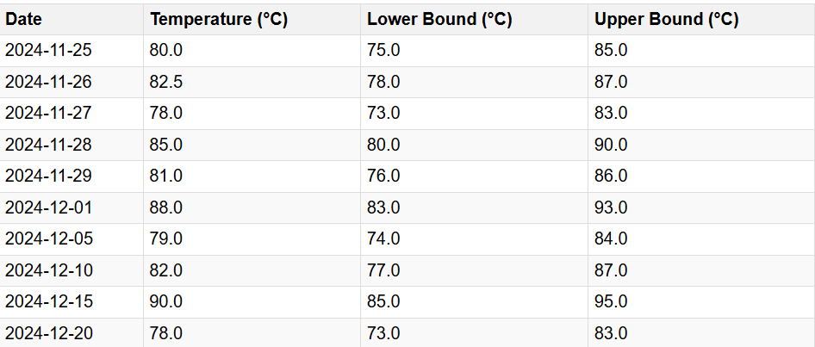

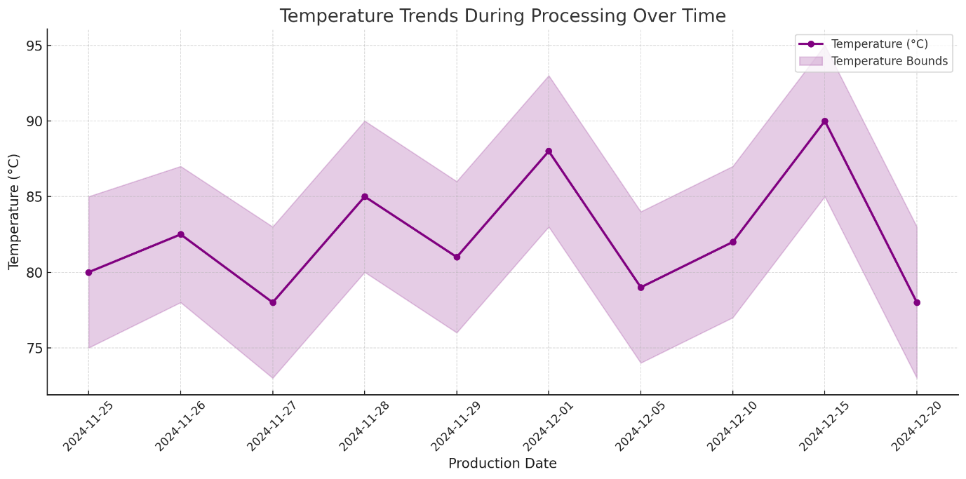

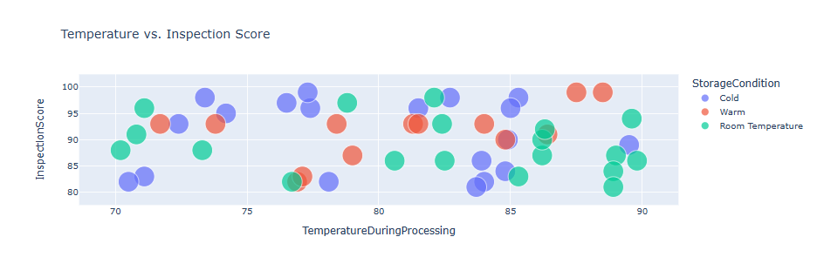

**Table 6: Summary Statistics for Storage Conditions**

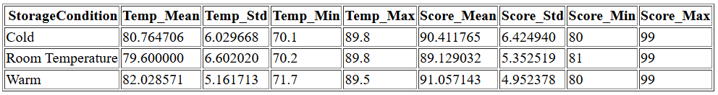

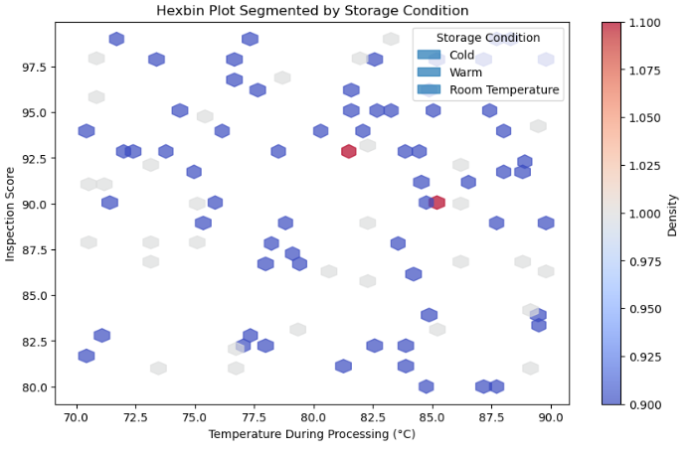

**Table 7: Temperature Distribution by Status Across Processing Stages**

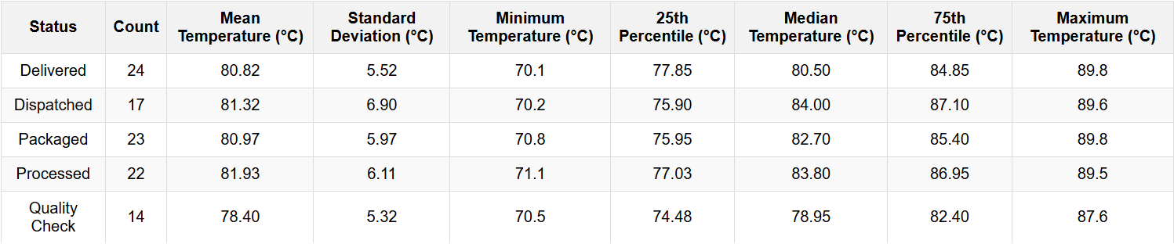

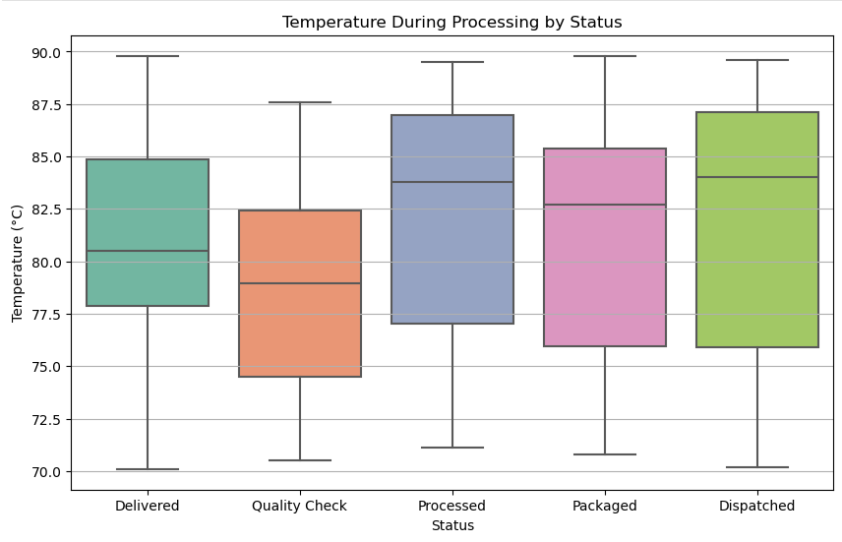

**Table 8: Temperature and Inspection Score Metrics**

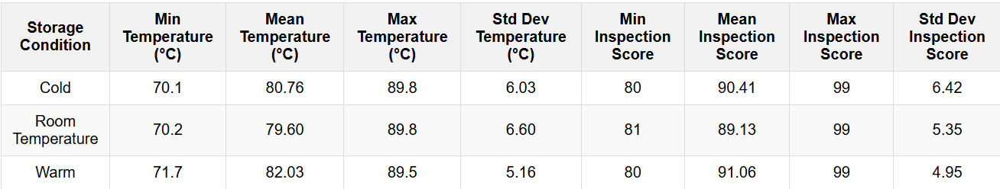

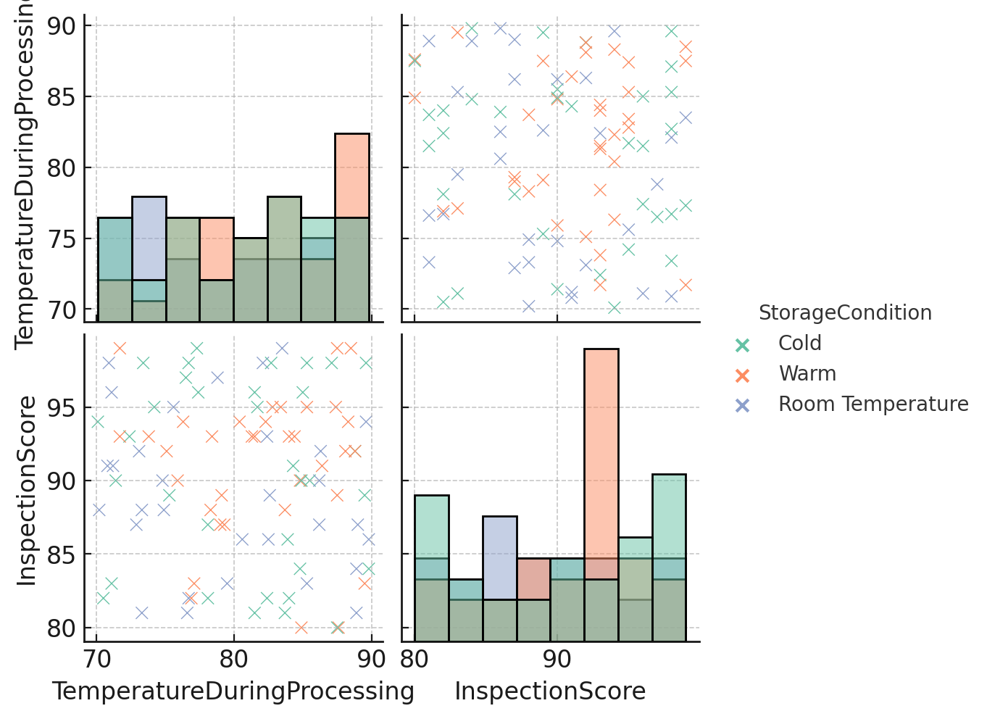

**Blockchain Success Factors for Dairy Supply Chain Management**

Blockchain has proven itself to be a game-changer technology in the area of supply chain management. The presence of blockchain technology introduces aspects of transparency, trust and decentralization into the supply chains. The following Table lists some of the prominent success factors leading to the adoption of blockchain technology for dairy supply chain management

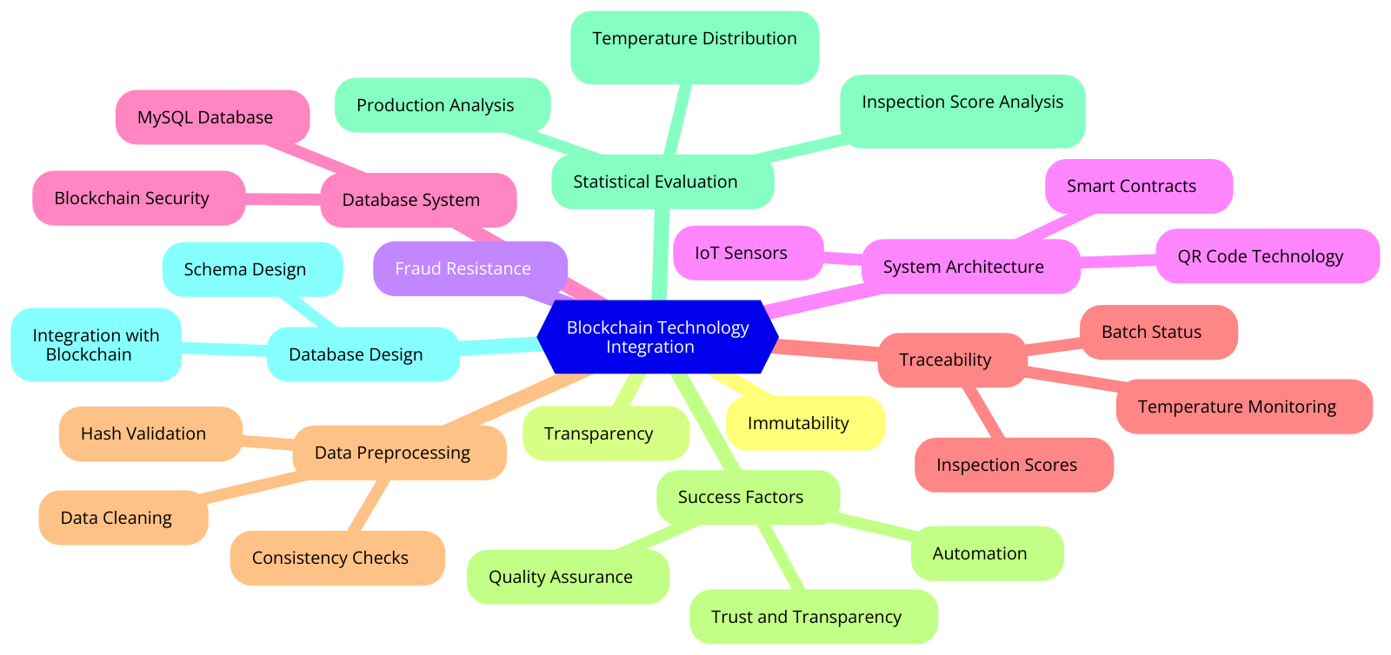

| **Success Factor** | **Description** |
| --- | --- |

|  |  |
| --- | --- |
|  | |
| **Traceability** | |  |  | | --- | --- | |  | Blockchain facilitates a stakeholder to track the movement of a particular dairy product across the entire supply chain. The presence of a particular dairy product or a batch or a complete order can be traced by every stakeholder. | | |
| **Transparency** | |  |  | | --- | --- | |  | All stakeholders within the supply chain are aware of any transaction being performed. Information regarding a particular dairy product or a complete order is accessible to all stakeholders without any partiality. | | |
| **Trust** | |  |  | | --- | --- | |  | Blockchain enables the establishment of trust between different stakeholders in the supply chain. Most importantly, it prevents the occurrence of a trust deficit between the end consumer and the dairy company. | | |
| **Knowledge Sharing** | |  |  | | --- | --- | |  | Blockchain can assist in sharing valuable insights regarding the distribution and sales of a particular dairy product across different distributors and retailers. The important aspect is the safe and secure mechanism of sharing knowledge. | | |
| **Smart Contracts** | |  |  | | --- | --- | |  | The most essential aspect of any blockchain solution is the use of smart contracts. They enable seamless transactions between stakeholders. Purchasing a product, managing multi-modal shipments, and removing a product are some of the many uses of smart contracts. | | |
| **Tokens** | |  |  | | --- | --- | |  | Financial settlements can be made possible by the use of cryptocurrency tokens. Apart from methods such as cash and credit, tokens are more flexible, secure, and fast when it comes to handling payment settlements. | | |
| **Immutability** | |  |  | | --- | --- | |  | The data stored on the blockchain is immutable in nature, i.e., once created it cannot be edited. A transaction once completed between two stakeholders cannot be revoked. | | |
| **Auditable** | |  |  | | --- | --- | |  | Unlike traditional dairy supply chains, blockchain-enabled supply chains are auditable as every transaction performed within the blockchain network is recorded and stored on individual blocks in a secured manner using cryptographic hash functions. | | |
| **Quality Assurance** | |  |  | | --- | --- | |  | Blockchain enables maintaining the quality of a dairy product throughout the supply chain. The use of blockchain assists in enforcing regulatory standards concerning the production, distribution, and storage of dairy products. | | |
| **Decentralized** | |  |  | | --- | --- | |  | Blockchain-enabled supply chains are decentralized in nature thereby preventing any possibility of a single point of failure. Moreover, the decentralized nature prevents chances of data manipulation and spreading misinformation to other stakeholders. | | |
| **Automation** | |  | | --- | | Blockchain integration supports the highest levels of automation in the functioning of the supply chain. Updation of product information, payment settlements, removing a product, adding a stakeholder, and all functionalities are automated using the blockchain. | | |
| **Removing Intermediaries** | |  | | --- | | Unlike traditional supply chains, blockchain-enabled supply chains are devoid of intermediaries. Transactions are performed only between legitimate stakeholders ensuring the safety of the dairy products. Unauthorized stakeholders are not permitted to perform transactions or even enter their products into the supply chain. | | |

**UHT milk class diagram**

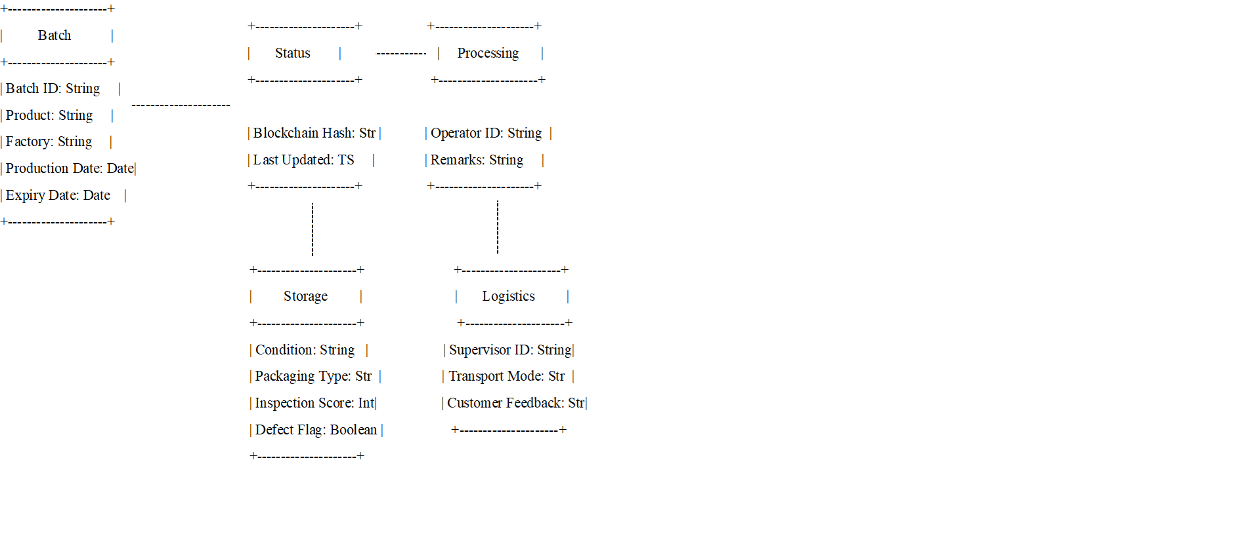

**Database Design**

The database contract serves as the starting point for all actions on the SQL database and is only ever deployed once for each database instance when it is created. A new database contract had to be delivered each time we added a new table or modified how tables and relationships were structured, because in an earlier version, we had tightly coupled the database schema and business logic into a single contract. Integrating document processing into the database schema would be even worse, as doing so would necessitate extensive modifications and redeployments whenever new data types or relationships were introduced.

We will now discuss how we implemented our smart contracts using Solidity, our SQL-based relational database, and an online user interface, along with a sample database design for our software application. Before entering the blockchain technology system, information about food safety is stored in the SQL database, as illustrated in the provided schema.

This SQL-based approach ensures structured, reliable, and relational data management while enabling secure integration with blockchain technology for tamper-proof record-keeping.

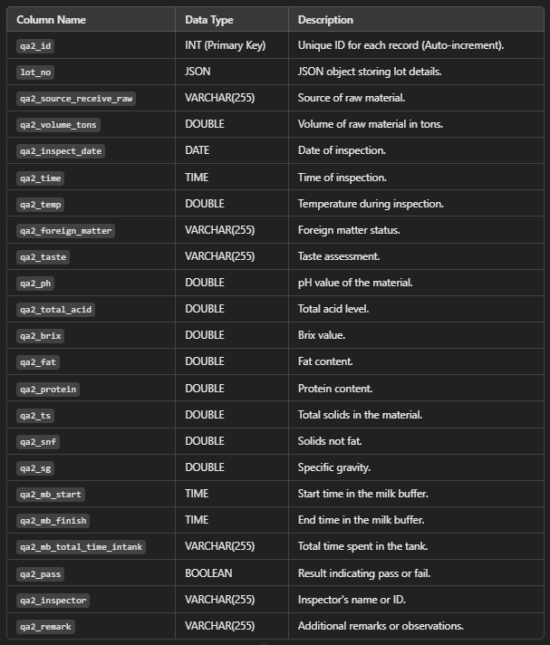

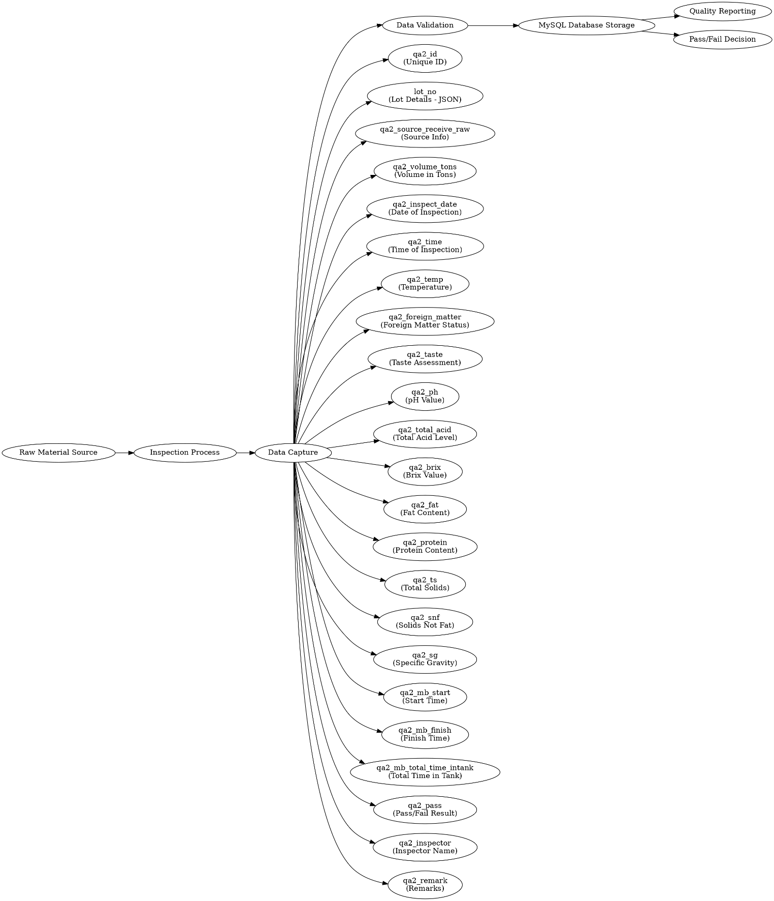

**Analysis Results**

1. **Integration of Blockchain Technology**:
   * The document highlights the use of blockchain technology in UHT milk production at the Chiangmai Fresh Milk Factory to improve food safety management.
   * Blockchain ensures immutability, transparency, and decentralized verification of critical data, making the system resistant to tampering and fraud.
2. **System Architecture**:
   * The architecture combines smart contracts, QR code technology, IoT sensors, and blockchain for efficient data collection, validation, and storage.
   * The system addresses multiple dimensions: social, economic, operational, and sustainability.
3. **Database System**:
   * MySQL serves as the relational database for structured data storage. Blockchain integration ensures data security and integrity.
   * The database architecture supports data preprocessing methods such as duplicate removal, data type formatting, and hash generation for immutable record-keeping.
4. **Traceability Features**:
   * The integration of IoT sensors and operator inputs ensures seamless data capture and traceability.
   * Key traceable elements include temperature during processing, inspection scores, operator details, and batch status.
5. **Data Preprocessing**:
   * Extensive methods are employed, including data cleaning, consistency checks, and the enrichment of datasets with derived columns like hash validations.
   * Preprocessing ensures the dataset is clean, consistent, and ready for analysis or integration into blockchain.
6. **Blockchain Success Factors**:
   * The document outlines critical factors such as traceability, transparency, trust, automation, quality assurance, and removal of intermediaries, which enhance the efficiency of the supply chain.
   * Smart contracts facilitate seamless transactions and regulatory compliance.
7. **Statistical Evaluation**:
   * Several tables provide a detailed statistical evaluation of production, temperature distribution, inspection scores, and storage conditions.
   * The correlation between key variables is analyzed to ensure data consistency and to optimize quality control processes.
8. **Database Design**:
   * The database schema is designed to ensure structured, reliable data management.
   * SQL-based relational management facilitates efficient integration with blockchain

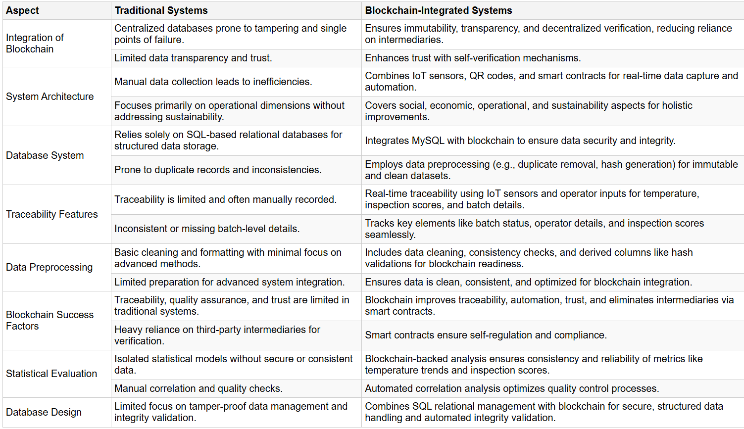

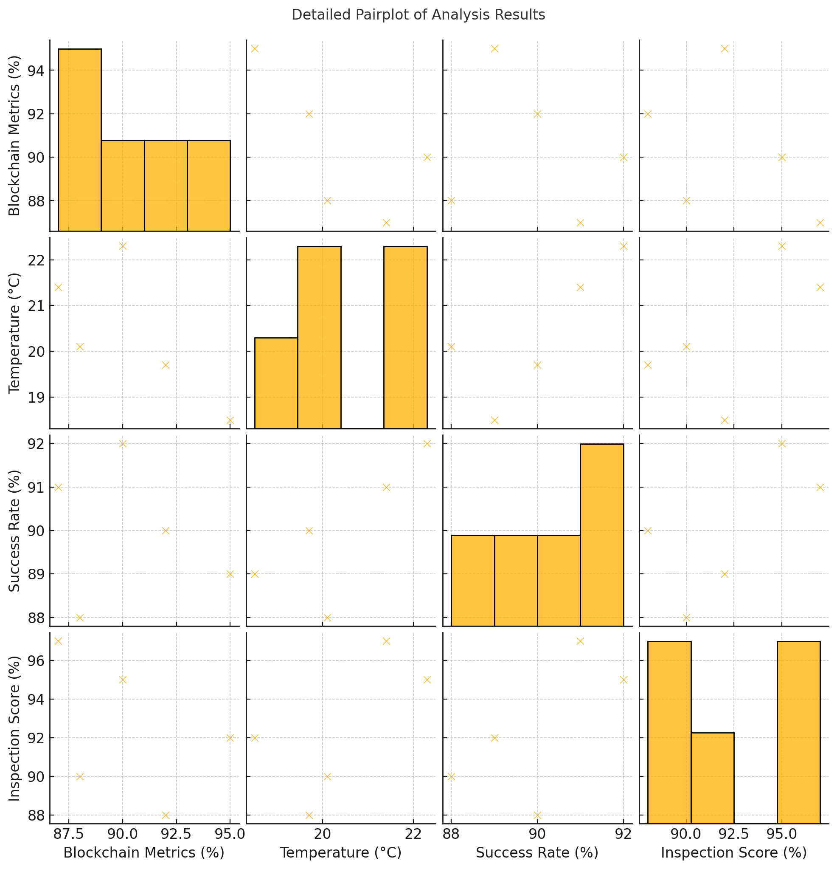

**Conclusion**

The implementation of blockchain technology in the UHT milk production process at Chiangmai Fresh Milk Factory is a transformative step toward modernizing food safety management. By leveraging the immutability, transparency, and decentralization offered by blockchain, the system ensures tamper-proof data recording, efficient traceability, and real-time feedback.

The integration of MySQL databases with blockchain allows for structured data management while retaining the flexibility to adapt to evolving production needs. Furthermore, the automation of data capture and validation through IoT sensors, QR codes, and smart contracts significantly reduces operational inefficiencies.

This approach not only aligns with global trends in food traceability and quality assurance but also fosters consumer trust by providing verifiable safety data. However, initial implementation challenges, such as reliance on IoT infrastructure and operator inputs, need to be addressed for smoother adoption.

The project's success demonstrates the potential of blockchain technology to redefine food safety protocols in the dairy industry and serves as a scalable model for other sectors. Moving forward, this framework could be expanded to include AI-driven analytics for predictive quality control, further enhancing operational efficiency and consumer satisfaction.

**Comparison and Conclusion:**

* **Performance Comparison:**
  + Blockchain-integrated database significantly enhances traceability and security.
  + Reduced fraud risk and improved transparency in food safety monitoring.
* **Key Findings:**
  + Blockchain technology ensures tamper-proof data recording.
  + Automated smart contract transactions streamline compliance processes.
* **Future Work:**
  + Integration of AI-driven anomaly detection in food safety monitoring.
  + Expansion to multi-factory implementations for scalability.